OSSP (Operating Systems And Systems Programming) - 25CS2104E

Skill 2

- To Create Main Loop, Display Prompt, Read User Input, Handle Exit Conditions, Design Control Flow Diagram, Test Interactive Loop
To Capture Keyboard Input, Handle Backspace, Process Enter Key, Manage Input Buffer, Support Multi-Character Commands, Test User Interaction

STEP 1 - OPEN TERMINAL

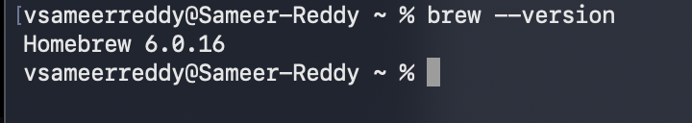
STEP 2 - CHECK HOMEBREW

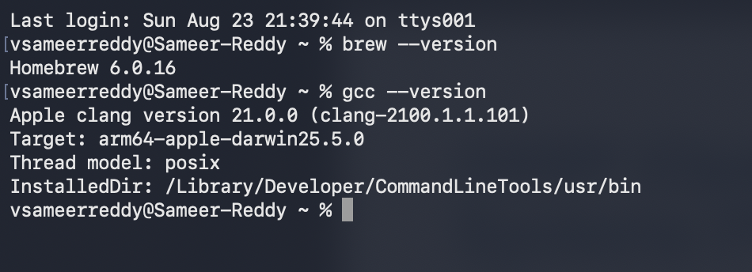
STEP 3 - CHECK GCC

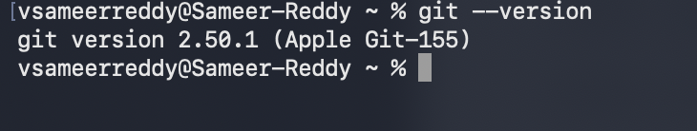
STEP 4 - CHECK GIT

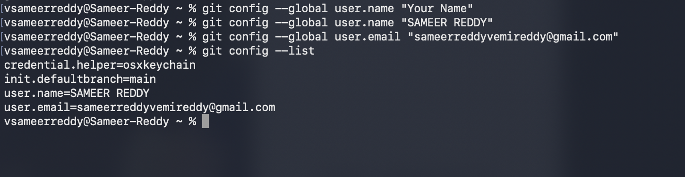
STEP 5 - CONFIGURE GIT

STEP 6 - CREATE THE PROJECT STRUCTUE
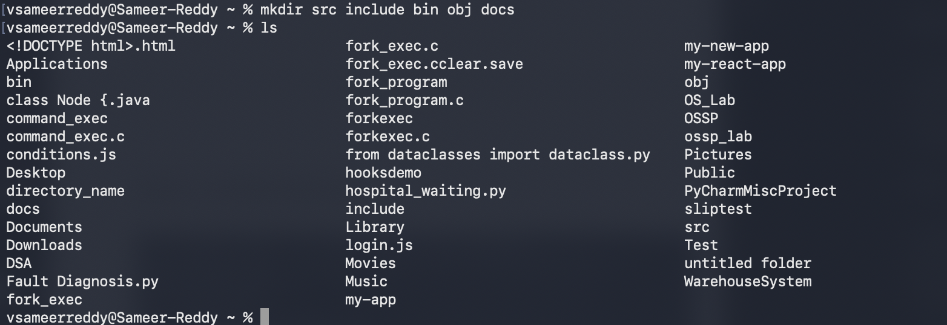

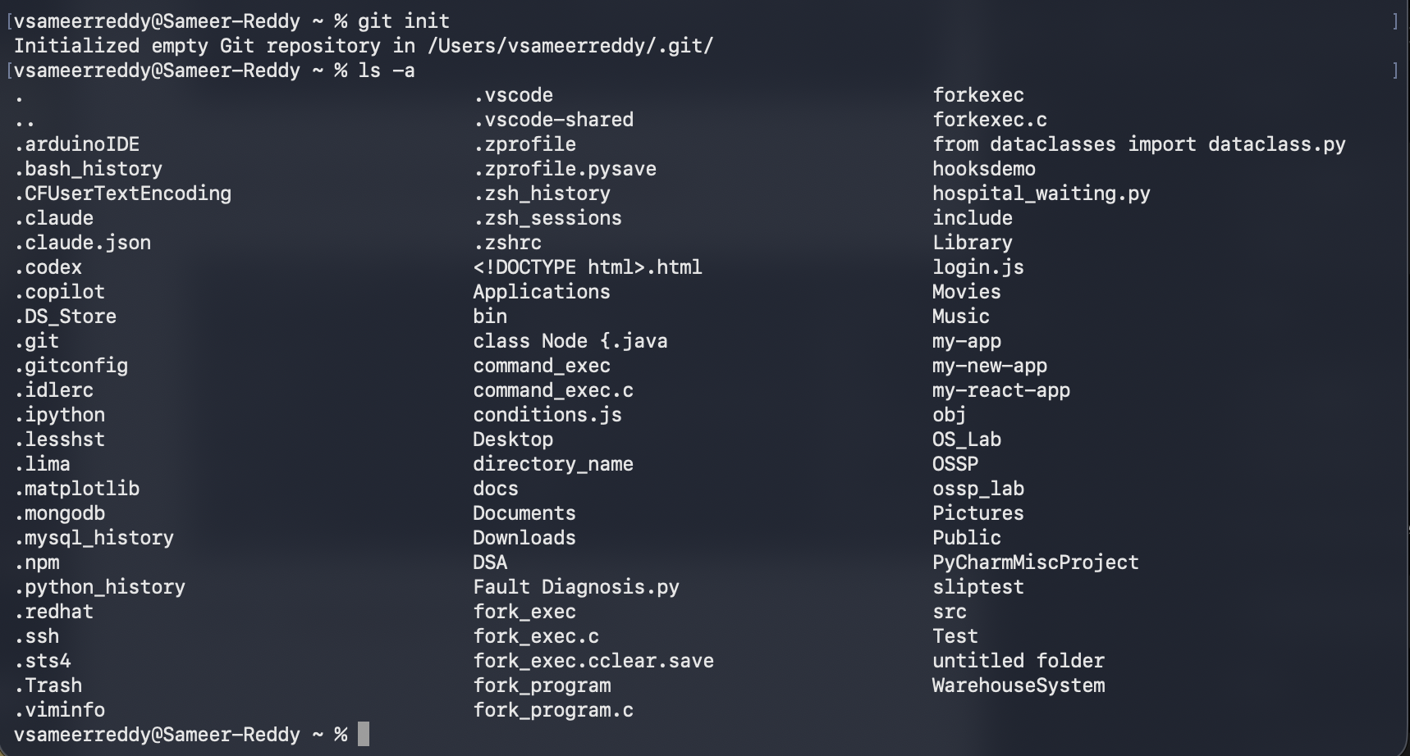
STEP 7 - INITIALIZE GIT REPOSITORY

STEP 8 - CREATE C PROGRAM
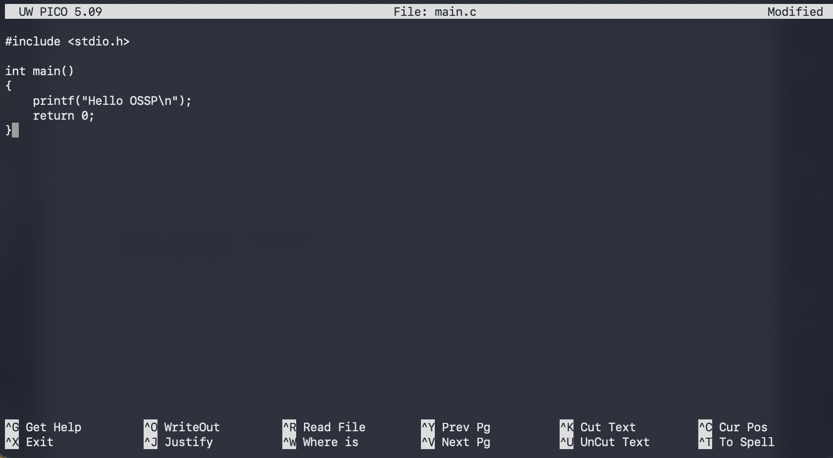
TYPE THE CODE AND SAVE THE FILE

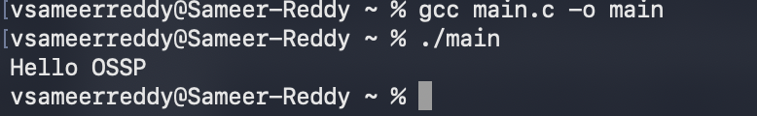
STEP 9 - COMPILE AND RUN

STEP 10 - EXECUTE SHELL COMMANDS
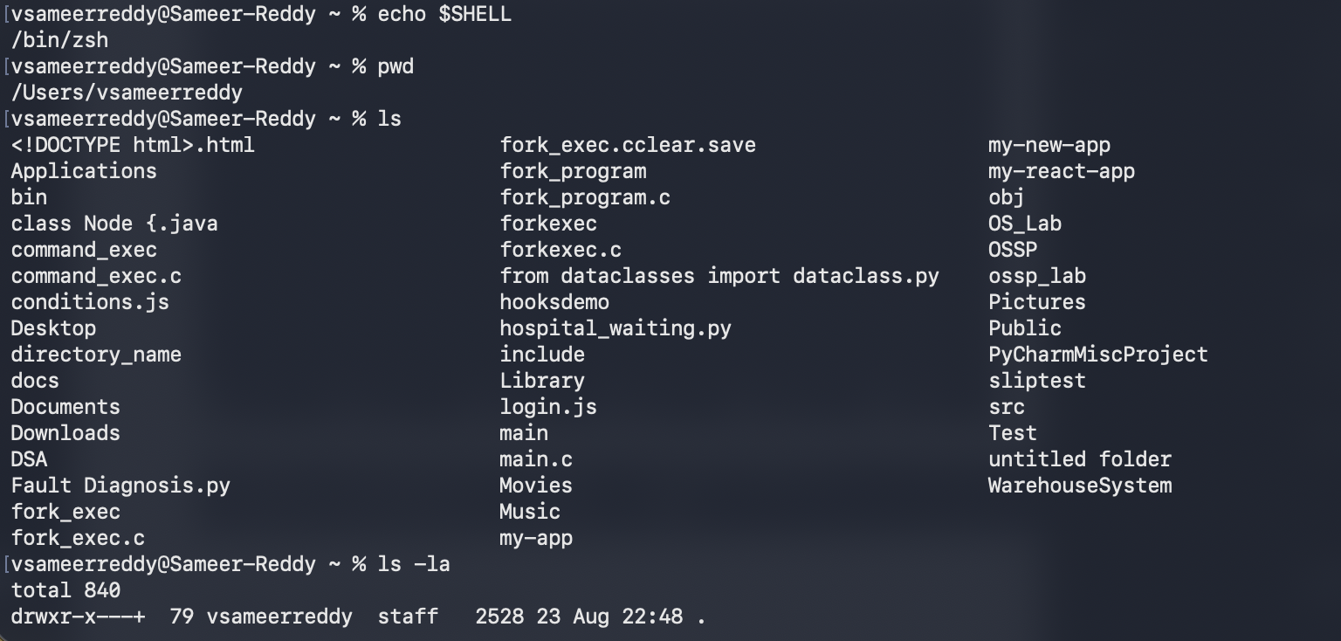
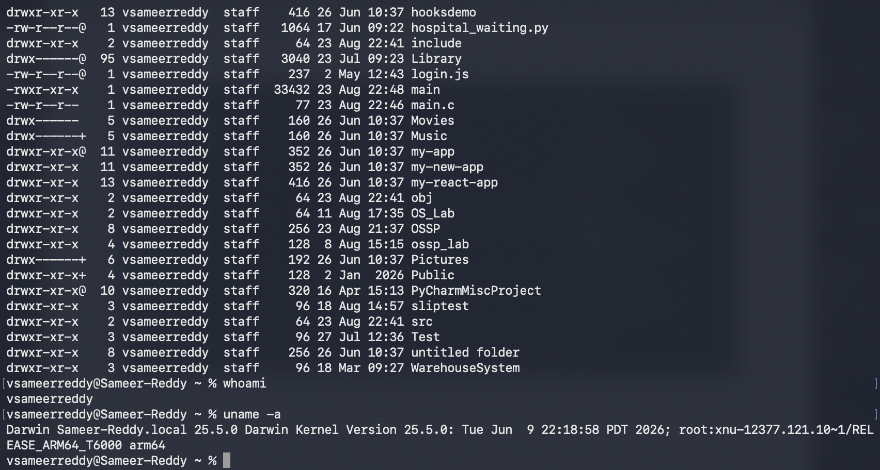
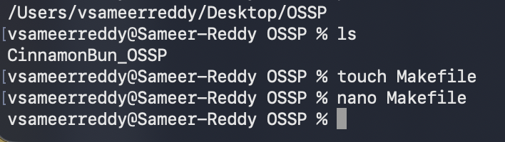
STEP 11 - CREATE MARKET FILE

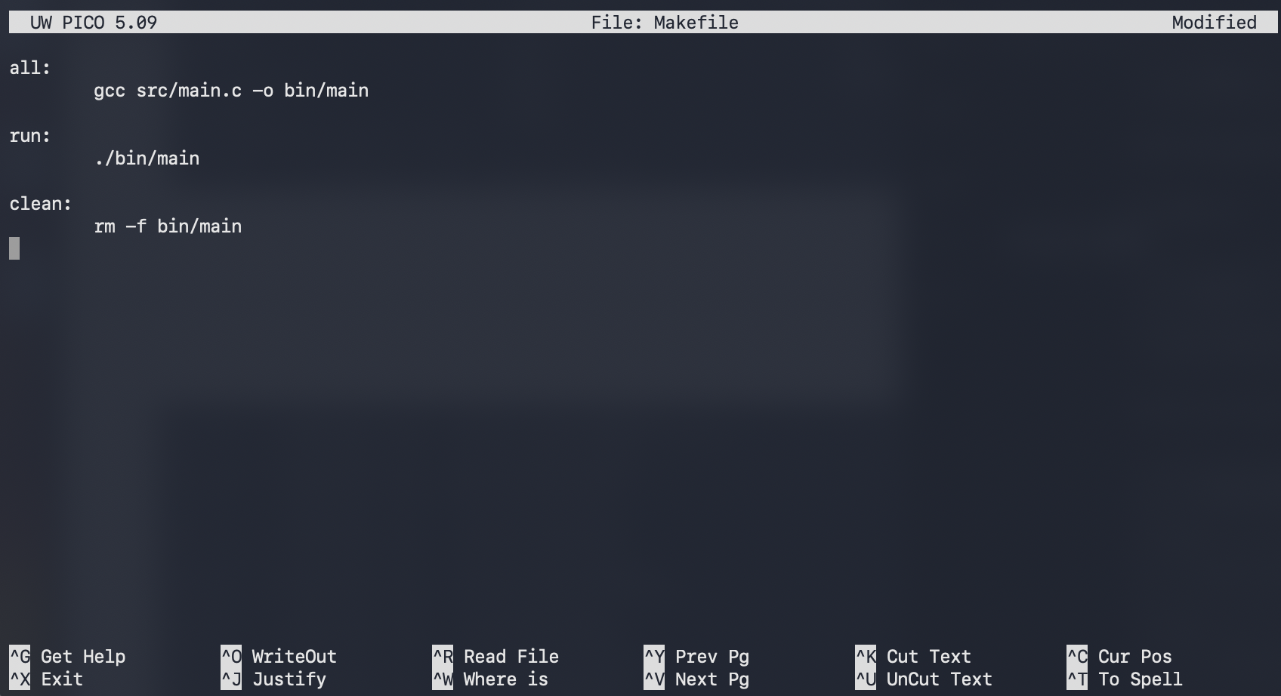

Step 12 - Run Makefile
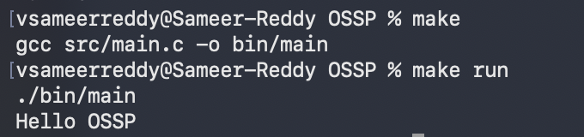

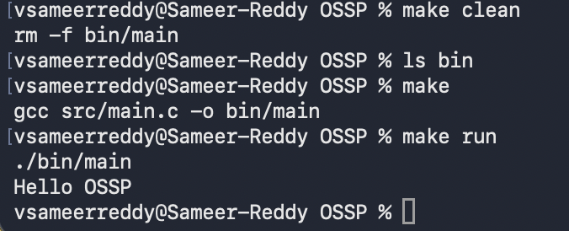

STEP 13 -

